ACCESSING THE SERVER IN AWS
NAME: SRIDHAR S
ROLL - NO: 23ISR055
Step 1: Creating an AWS Account:
This step involves registering for an account in Amazon Web Services (AWS) to access cloud computing service.
Visit:https://aws.amazon.com → Click Create an AWS Account → Complete registration and billing setup.
Step 2: Launching an EC2 Instance
This step involves creating a virtual server using the Amazon EC2 service inside AWS that allows users to deploy scalable virtual machines in the cloud for application hosting and development.
Procedure:
- Login to AWS Management Console
- Navigate to EC2 Dashboard
- Click Launch Instance
- Choose Ubuntu Server AMI
- Select Instance Type (e.g., t3.micro – Free Tier eligible)
- Create or select a Key Pair
- Configure Security Group (Allow SSH – Port 22)
- Click Launch Instance

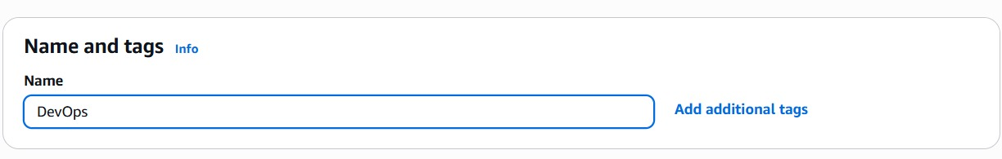

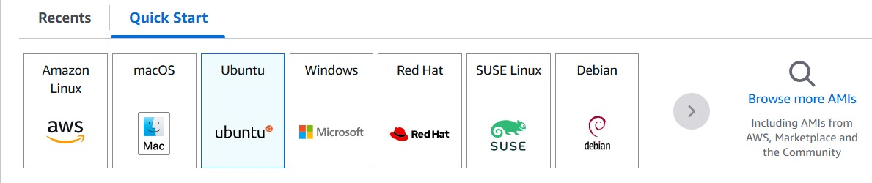

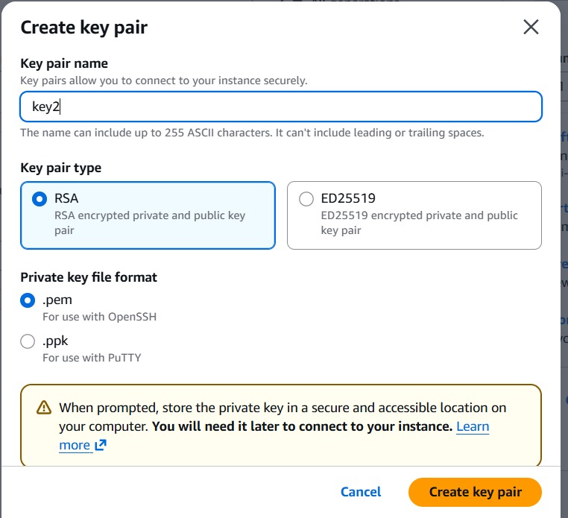

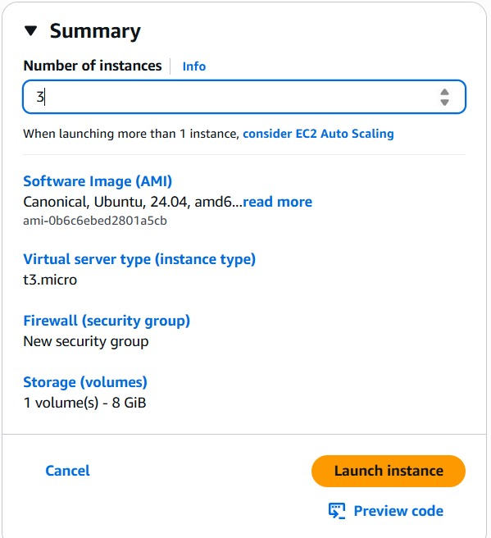

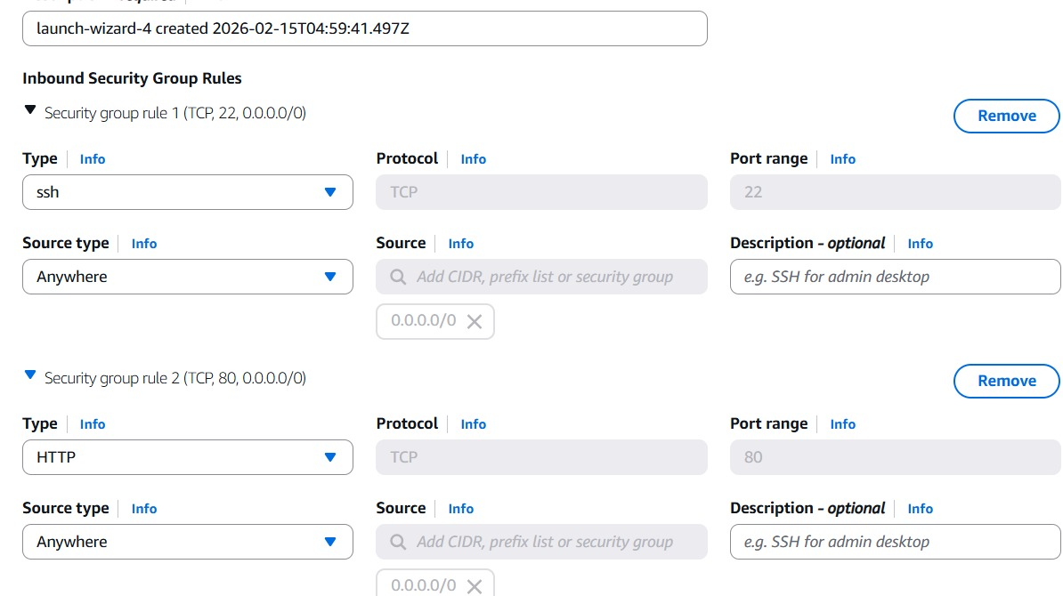

Step 3: Connecting to the EC2 Instance
This step establishes a secure connection to the created EC2 virtual machine using SSH. It allows remote access to configure software and manage the server.
Command to Run (from local terminal):
ssh -i your-key.pem ubuntu@your-ec2-public-ip
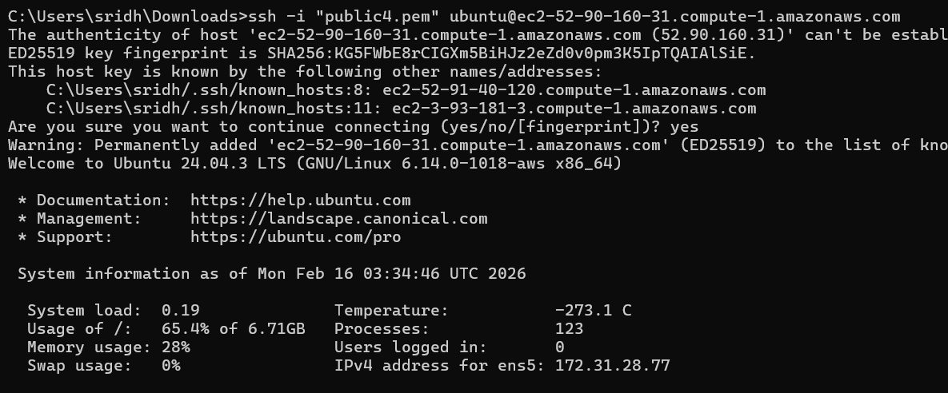

Step 5: Installing Docker
Installing Docker on the Ubuntu EC2 instance to enable containerized application deployment.
Command to Run:
sudo apt install docker.io

Step 6: Updating Docker
This updates the Docker package to the latest available version from the Ubuntu repositories. If required verify the version of the docker.
Command to Run:
  - sudo apt update
  - docker --version
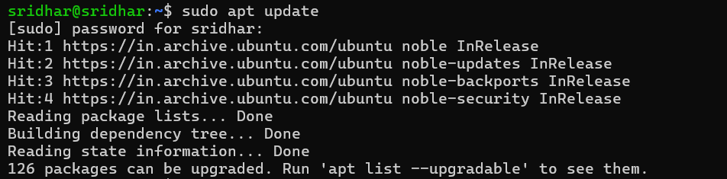

Step 7: Starting Docker Service
This step starts Docker and ensures it automatically runs during system boot.
Enabling the service guarantees continuous container availability after restart.
Commands to Run:
sudosystemctl start docker

Step 8: Installing Jenkins Prerequisites (OpenJDK 21)
This step installs the required Java runtime environment needed to run Jenkins on Ubuntu.Jenkins requires Java to execute, and OpenJDK 21 is the recommended supported version.
Commands to Run:
- sudo apt update
- sudo apt install fontconfig openjdk-21-jre -y
- java -version
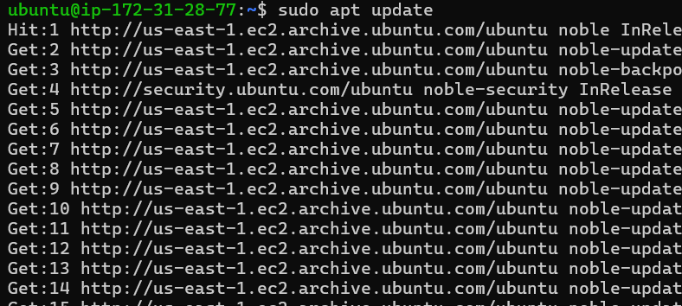
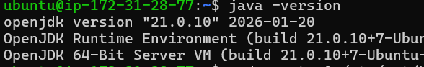

Step 9: Adding Jenkins LTS Repository (Debian/Ubuntu)
This step adds the official Jenkins Long-Term Support (LTS) repository to the system.The LTS version provides a stable and production-ready Jenkins release.
Commands to Run:
- sudowget -O /etc/apt/keyrings/jenkins-keyring.asc \
https://pkg.jenkins.io/debian-stable/jenkins.io-2026.key
echo "deb [signed-by=/etc/apt/keyrings/jenkins-keyring.asc]" \
https://pkg.jenkins.io/debian-stable binary/ | sudo tee \
/etc/apt/sources.list.d/jenkins.list> /dev/null
- sudo apt update
- sudo apt install Jenkins
